# Groshong Algorithms Lab 3

**Implement the DP version of MCM algorithm. Show commented code.**

I used the pseudocode from the book in combination with explanations and code examples from [geekforgeek](https://www.geeksforgeeks.org/dynamic-programming-set-8-matrix-chain-multiplication/), and [sanfoundry](https://www.sanfoundry.com/java-program-perform-optimal-paranthesization-using-dynamic-programming/) and a [video](https://www.youtube.com/watch?v=GMzVeWpyTN0) from youtube to refresh how it works. I have a terrible time with keeping track of nested for loops when using them to fill a table. The pseudocode is what I relied on but it also messed with me since I always forget they start arrays from 1 which I always forget.

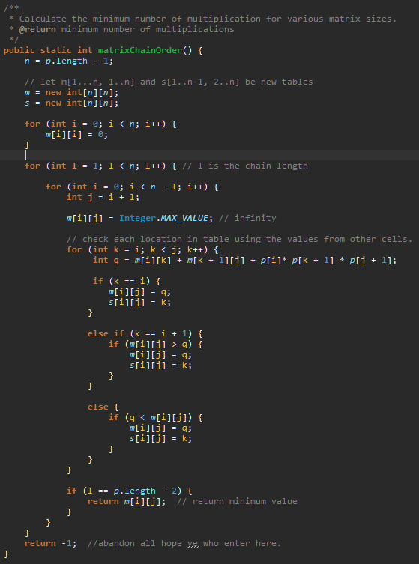

**Show the output for your DP version of MCM algorithm for p being < 30, 4, 8, 5, 10, 25, 15>, including where the parenthesis should be located.**

